Assignment 3
(Last Date for Submission is 18th Mar 2015)
If the assignment is not submitted within the deadline you will get 0 (Zero) marks for this assignment.
1.Given the following total cost function TC = 1500 + 15Q – 6Q² + Q³.
- Determine the total fixed cost for producing 1000 units of output and 500 units of output.
- What is AFC at (a) 1000 units of output, and (b) 500 units of output?
- Determine TVC, AVC, MC and AC at 50 and 5000 units of output.
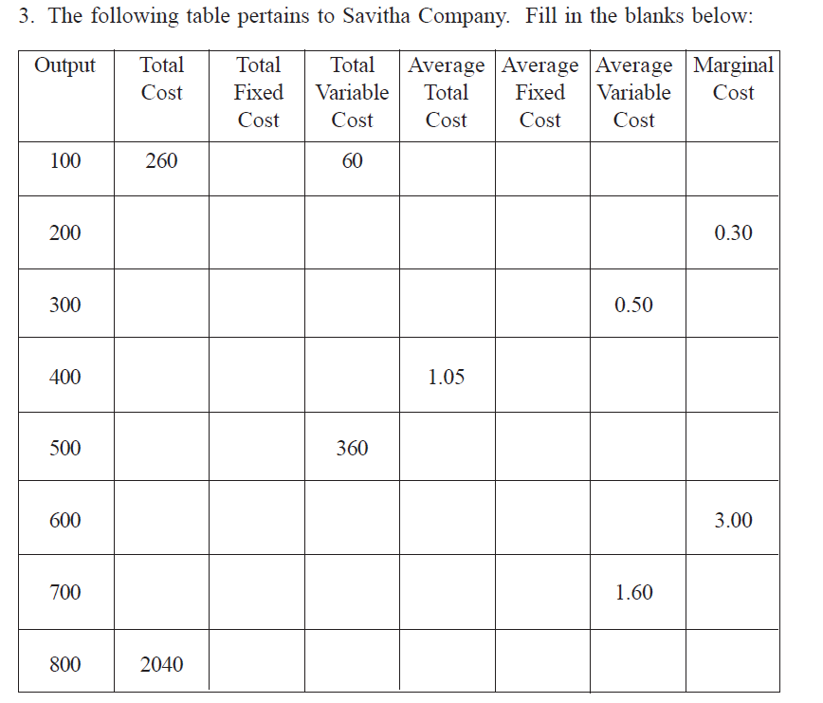

5..The various possible combinations of two inputs, labour and capital, which can produce 100 units of output are given as under:
L = 2 3 4 5 6
K = 20 15 12 10 9
If the prevailing prices of labour and capital are Rs. 15 per unit and Rs. 12 per unit, find out the least cost combination of these inputs.
- Suppose a firm faces a cost function of C= 8 + 4q +q² . What is the firm’s fixed cost? Derive an expression for the firm’s variable cost and marginal cost. Compute the TFC, TVC, TC, AVC, AFC, AC and MC for 0, 1, 2, 3, 4, 5, 6,7,8,9 and 10 units of output and plot it graphically to show the shape of the respective curve.

6. Given the total cost function TC = 1000 + 4Q + 0.5Q². Determine the functions for TFC, TVC, MC, AVC and AC.

7.Given is the short run total cost function: TC= 100 + 50Q – 12Q² + Q³ where TC is total cost and Q is level of output.

- Determine total fixed cost function, total variable cost function, average variable cost function and marginal cost function.
- Calculate total cost, ATC, AVC and MC when the firm produces 10 units of output.
- Calculate the level of output at which AVC is minimum.

8.Given is the short run total cost function: TC= 100 + 50Q – 12Q² + Q³ where TC is total cost and Q is level of output
a. Determine total fixed cost function, total variable cost function, average variable cost function and marginal cost function.
b. Calculate total cost, ATC, AVC and MC when the firm produces 10 units of output.
c. Calculate the level of output at which AVC is minimum.
9.Firms average cost is Rs 300 at 5 units of output and Rs 320 at 6 units of output. Calculate the marginal cost of 6th unit of output?
10.Firm producing 7 units of output has an Average Total Cost of Rs 150 and has to pay Rs 350 as fixed cost whether it produces or not. How much of Average Cost is made up of Variable Cost?
11.Firm has variable cost of Rs 1000 at 5 units of output. If Fixed costs are Rs 400 what will be Average Total Costs at 5 units of Output?
12. The Input-Output matrix for a firm is as follows:
L / K | 20 | 40 | 60 | 80 | 100 | 120
120 | 144 | 160 | 180 | 208 | 236 | 256
100 | 120 | 152 | 168 | 192 | 220 | 236
80 | 96 | 144 | 160 | 180 | 196 | 216
60 | 76 | 120 | 144 | 160 | 180 | 188
40 | 56 | 96 | 120 | 132 | 144 | 160
20 | 40 | 64 | 96 | 120 | 128 | 140

Labor (L) and Capital (K) are used as inputs to produce outputs (Q). Labor is presented column-wise and Capital is presented row-wise whereas inner boxes denote the number of units produced as output. Based on the given output data table, plot graphically any two isoquants. Also suggest the input pairs which exemplify the increasing, constant and decreasing returns to scale.

